CLASS PROJECT

COMPUTER COMMUNICATION AND NETWORKS

Name: Jawad Ali

CMS ID: 033-22-0001

CLASS: BE-III [Electronics]

Sukkur IBA University has two campuses situated in Sukkur and Khairpur, both are 30 kilometers apart. The University has around 5000 students and 1000 staff and faculty members distributed in 6 different departments. These departments include Business administration, Computer science, Electrical and Computer System Engineering, Education and Mathematics, Media science and Physical Sciences. Each staff and faculty members has access to Pc and students have access to PCs in the labs.

Project requirements:

1. Create a network topology with the main components to support the following:

# Sukkur Campus

* + 1. Administration Block: All admin offices like HR, Finance, Audit, IT are located in admin block. The admin staff PCs are distributed in the building offices and it is expected that they share some networking equipment’s. [hint: use of VLANs in expected here]
    2. Academic Block 1: Computer Science department is located in this block plus Students Labs and University server and web server also present in this building
    3. Academic Block 2: Business Department
    4. Academic Block 3: Electrical and Computer System Engineering
    5. Academic Block 4: Education and Mathematics Department
    6. Academic Block 5: Media Science and Physical Sciences

# Khairpur Campus:

* + 1. This campus also has Department like Business Administration and Computer science.
  1. You will be expected to configure the core devices and few end devices to provide end to end connectivity the access to the internal server, external server and sukkur IBA webpage.
  2. Each department is expected to be on its own separate IP Network
  3. The switches should be configured with appropriate VLANs and security settings
  4. No academic department is allowed to access the finance department
  5. HR department have access to all the departments
  6. Academic blocks have access to IT department and vice versa
  7. The devices in all buildings will be expected to acquire dynamic IPv4 addresses from a router based DHCP server.
  8. Each department is required to be in different VLANs
  9. Each department is required to have wireless access as well for the users
  10. Assume your ISP gave out a base network of 192.168.1.0.
  11. RIPv2 will be used to provide routing for the routers in the internal network and static routing for the external server.

Configure the Network in packet tracer with all appropriate settings to achieve the connectivity and functionalities specified in the requirements.

**Good Luck Submission Date: 15 Dec 2023**

**Network:**

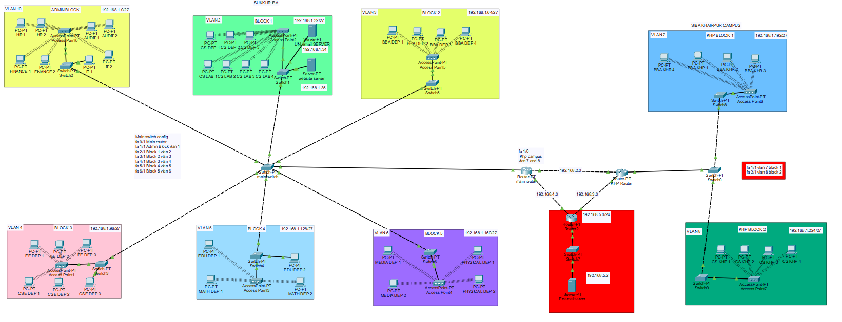

**This network is consist of three network:**

1. **Siba main Campus**

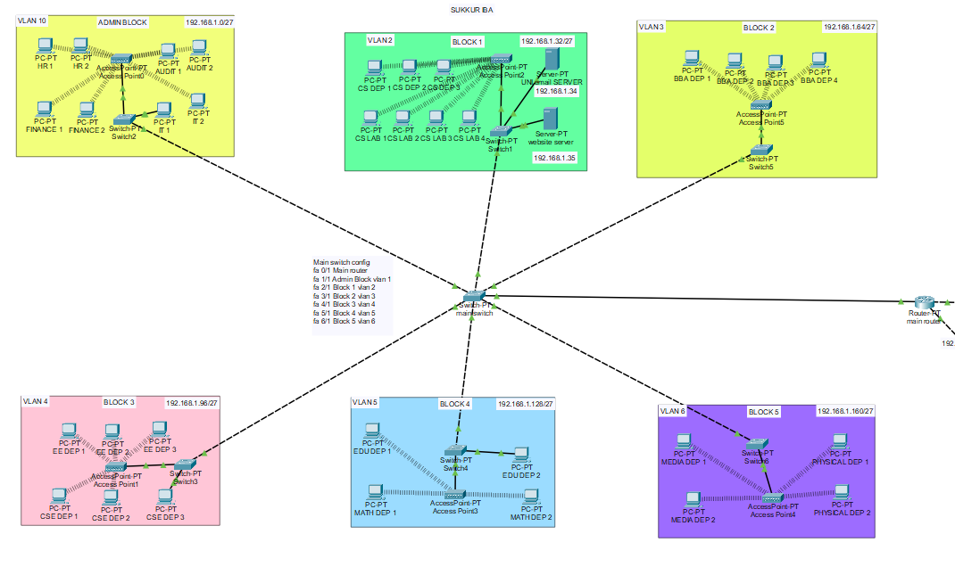

1. **Siba Khairpur Campus External network**

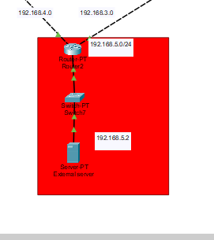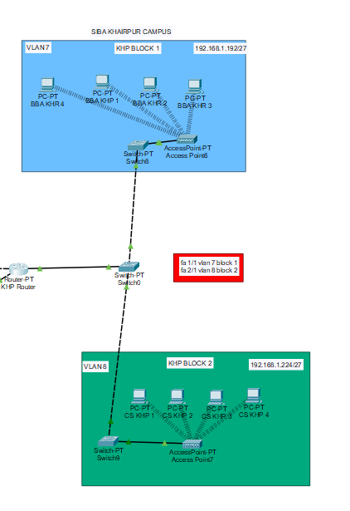

**Subnetting:**

**Main Campus Subnetting**

**Vlan 10 - Admin Block - 192.168.1.0/27**

**Vlan 2 - Academic Block 1 - 192.168.1.32/27**

**Vlan 3 - Academic Block 2 - 192.168.1.64/27**

**Vlan 4 - Academic Block 3 - 192.168.1.96/27**

**Vlan 5 - Academic Block 4 - 192.168.1.128/27**

**Vlan 6 - Academic Block 5 - 192.168.1.160/27**

**Khairpur Campus subnetting**

**Vlan 7 - Academic Block 1 - 192.168.1.192/27**

**Vlan 8 - Academic Block 2 - 192.168.1.224/27**

Main Router Commands:

Router>en

Router#config t

Enter configuration commands, one per line. End with CNTL/Z.

Router(config)#int fa 0/0

Router(config-if)#no shut

Router(config-if)#

%LINK-5-CHANGED: Interface FastEthernet0/0, changed state to up

Router(config-if)#int fa 0/0.10

Router(config-subif)#encapsulation dot1q 10

Router(config-subif)#ip add 192.168.1.1 255.255.255.224

Router(config-subif)#ip dhcp pool pool1

Router(dhcp-config)#net 192.168.1.0 255.255.255.224

Router(dhcp-config)# dns 192.168.1.35

Router(dhcp-config)#default-router 192.168.1.1

Router(dhcp-config)#int fa 0/0.2

Router(config-subif)#

%LINK-5-CHANGED: Interface FastEthernet0/0.2, changed state to up

Router(config-subif)#encapsulation dot1q 2

Router(config-subif)#ip add 192.168.1.33 255.255.255.224

Router(config-subif)#ip dhcp pool pool2

Router(dhcp-config)#net 192.168.1.32 255.255.255.224

Router(dhcp-config)#default-router 192.168.1.33

Router(dhcp-config)# dns 192.168.1.35

Router(dhcp-config)#int fa 0/0.3

Router(config-subif)#

%LINK-5-CHANGED: Interface FastEthernet0/0.3, changed state to up

Router(config-subif)#encapsulation dot1q 3

Router(config-subif)#ip add 192.168.1.65 255.255.255.224

Router(config-subif)#ip dhcp pool pool3

Router(dhcp-config)#net 192.168.1.64 255.255.255.224

Router(dhcp-config)#default-router 192.168.1.65

Router(dhcp-config)# dns 192.168.1.35

Router(dhcp-config)#int fa 0/0.4

Router(config-subif)#

%LINK-5-CHANGED: Interface FastEthernet0/0.4, changed state to up

Router(config-subif)#encapsulation dot1q 4

Router(config-subif)#ip add 192.168.1.97 255.255.255.224

Router(config-subif)#ip dhcp pool pool4

Router(dhcp-config)#net 192.168.1.96 255.255.255.224

Router(dhcp-config)#default-router 192.168.1.97

Router(dhcp-config)# dns 192.168.1.35

Router(dhcp-config)#int fa 0/0.5

Router(config-subif)#

%LINK-5-CHANGED: Interface FastEthernet0/0.5, changed state to up

Router(config-subif)#encapsulation dot1q 5

Router(config-subif)#ip add 192.168.1.129 255.255.255.224

Router(config-subif)#ip dhcp pool pool5

Router(dhcp-config)#net 192.168.1.128 255.255.255.224

Router(dhcp-config)#default-router 192.168.1.129

Router(dhcp-config)# dns 192.168.1.35

Router(dhcp-config)#int fa 0/0.6

Router(config-subif)#

%LINK-5-CHANGED: Interface FastEthernet0/0.6, changed state to up

Router(config-subif)#encapsulation dot1q 6

Router(config-subif)#ip add 192.168.1.161 255.255.255.224

Router(config-subif)#ip dhcp pool pool6

Router(dhcp-config)#net 192.168.1.160 255.255.255.224

Router(dhcp-config)# dns 192.168.1.35

Router(dhcp-config)#default-router 192.168.1.161

%SYS-5-CONFIG_I: Configured from console by console

wr

Building configuration...

[OK]

Router#

Khairpur Campus router:

Router>en

Router#config t

Enter configuration commands, one per line. End with CNTL/Z.

Router(config)#int fa 0/0

Router(config-if)#no shut

Router(config-if)#

%LINK-5-CHANGED: Interface FastEthernet0/0, changed state to up

Router(config-if)#int fa 0/0.7

Router(config-subif)#encapsulation dot1q 7

Router(config-subif)#ip add 192.168.1.193 255.255.255.224

Router(config-subif)#ip dhcp pool pool7

Router(dhcp-config)#net 192.168.192.0 255.255.255.224

Router(dhcp-config)# dns 192.168.1.35

Router(dhcp-config)#default-router 192.168.1.193

Router(dhcp-config)#int fa 0/0.8

Router(config-subif)#

%LINK-5-CHANGED: Interface FastEthernet0/0.2, changed state to up

Router(config-subif)#encapsulation dot1q 8

Router(config-subif)#ip add 192.168.1.225 255.255.255.224

Router(config-subif)#ip dhcp pool pool8

Router(dhcp-config)#net 192.168.1.224 255.255.255.224

Router(dhcp-config)#default-router 192.168.1.225

Router(dhcp-config)# dns 192.168.1.35

**Dhcp pools:**

Router>en

Router#show ip dhcp pool

Pool pool1 :

Utilization mark (high/low) : 100 / 0

Subnet size (first/next) : 0 / 0

Total addresses : 30

Leased addresses : 0

Excluded addresses : 0

Pending event : none

1 subnet is currently in the pool

Current index IP address range Leased/Excluded/Total

192.168.1.1 192.168.1.1 - 192.168.1.30 0 / 0 / 30

Pool pool2 :

Utilization mark (high/low) : 100 / 0

Subnet size (first/next) : 0 / 0

Total addresses : 30

Leased addresses : 0

Excluded addresses : 0

Pending event : none

1 subnet is currently in the pool

Current index IP address range Leased/Excluded/Total

192.168.1.33 192.168.1.33 - 192.168.1.62 0 / 0 / 30

Pool pool3 :

Utilization mark (high/low) : 100 / 0

Subnet size (first/next) : 0 / 0

Total addresses : 30

Leased addresses : 0

Excluded addresses : 0

Pending event : none

1 subnet is currently in the pool

Current index IP address range Leased/Excluded/Total

192.168.1.65 192.168.1.65 - 192.168.1.94 0 / 0 / 30

Pool pool4 :

Utilization mark (high/low) : 100 / 0

Subnet size (first/next) : 0 / 0

Total addresses : 30

Leased addresses : 0

Excluded addresses : 0

Pending event : none

1 subnet is currently in the pool

Current index IP address range Leased/Excluded/Total

192.168.1.97 192.168.1.97 - 192.168.1.126 0 / 0 / 30

Pool pool5 :

Utilization mark (high/low) : 100 / 0

Subnet size (first/next) : 0 / 0

Total addresses : 30

Leased addresses : 0

Excluded addresses : 0

Pending event : none

1 subnet is currently in the pool

Current index IP address range Leased/Excluded/Total

192.168.1.129 192.168.1.129 - 192.168.1.158 0 / 0 / 30

Pool pool6 :

Utilization mark (high/low) : 100 / 0

Subnet size (first/next) : 0 / 0

Total addresses : 30

Leased addresses : 0

Excluded addresses : 0

Pending event : none

1 subnet is currently in the pool

Current index IP address range Leased/Excluded/Total

192.168.1.161 192.168.1.161 - 192.168.1.190 0 / 0 / 30

Router#

Router#

Router>en

Router#show ip dhcp pool

Pool pool7 :

Utilization mark (high/low) : 100 / 0

Subnet size (first/next) : 0 / 0

Total addresses : 30

Leased addresses : 4

Excluded addresses : 0

Pending event : none

1 subnet is currently in the pool

Current index IP address range Leased/Excluded/Total

192.168.1.193 192.168.1.193 - 192.168.1.222 4 / 0 / 30

Pool pool8 :

Utilization mark (high/low) : 100 / 0

Subnet size (first/next) : 0 / 0

Total addresses : 30

Leased addresses : 4

Excluded addresses : 0

Pending event : none

1 subnet is currently in the pool

Current index IP address range Leased/Excluded/Total

192.168.1.225 192.168.1.225 - 192.168.1.254 4 / 0 / 30

**Dhcp is configured on router to assign vlan using switch named main switch and switch0:**

**Main Campus Khairpur CAMPUS**

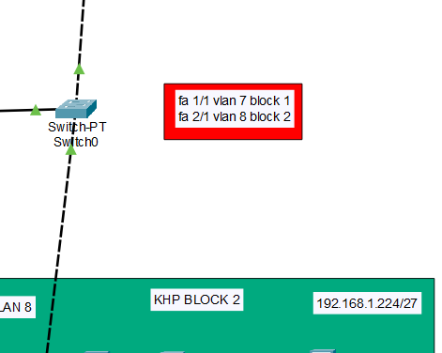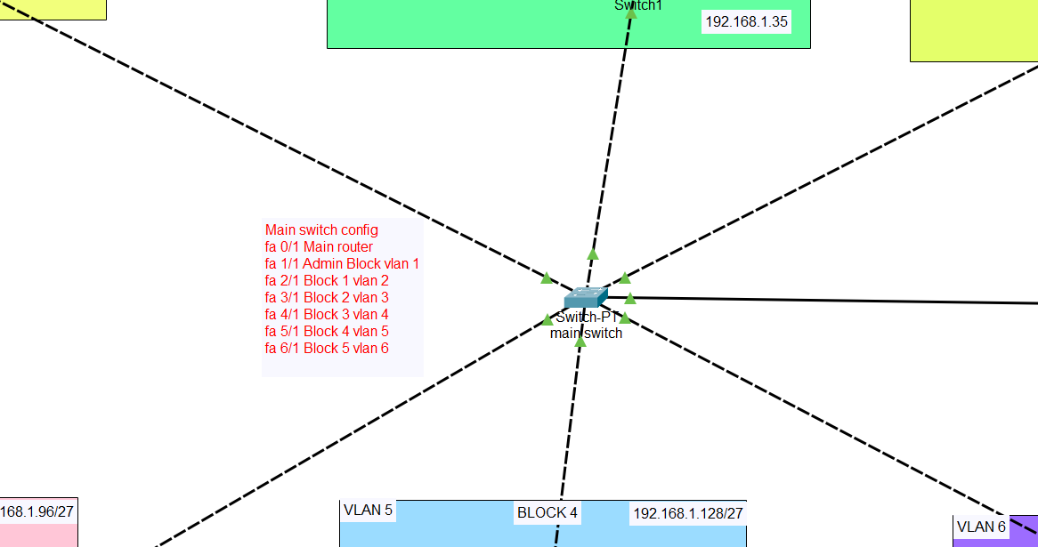

**In Each block users have choice to use wired or wireless connection:**

1. For wired used can connect to block switch.
2. For wireless access point is installed with password

To use wireless connection user needs antenna of 2.4Ghz frequency range,

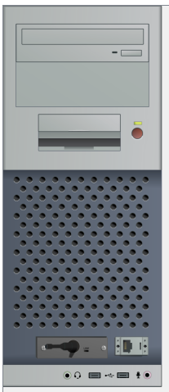

Password config of Admin Block Access point:

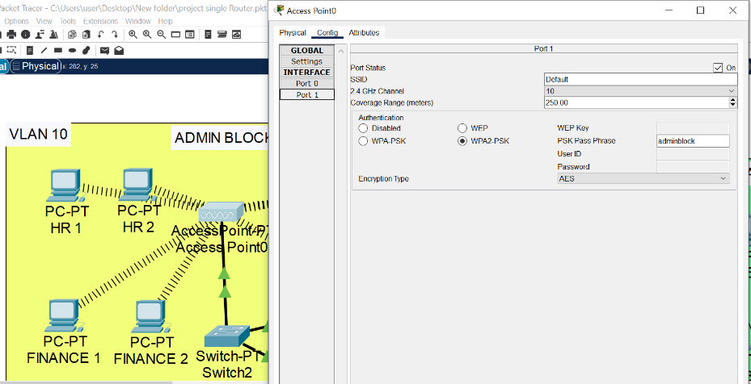

**Pc accessing admin block Access point:**

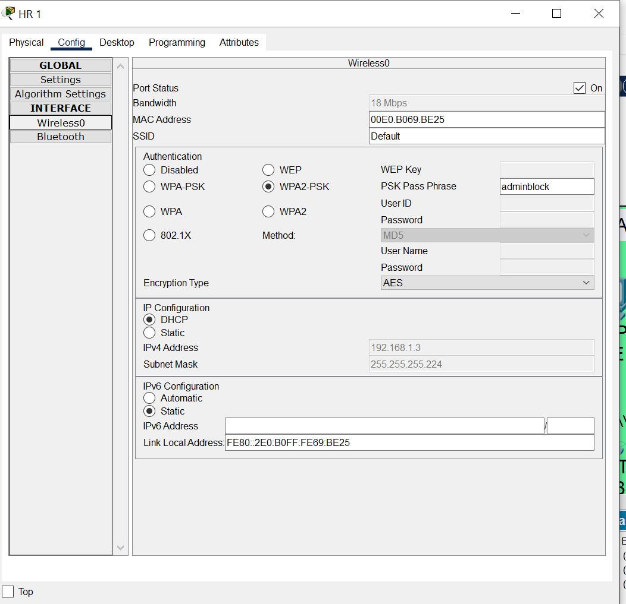

**Firewall config so that only admin block pcs can access finance department:**

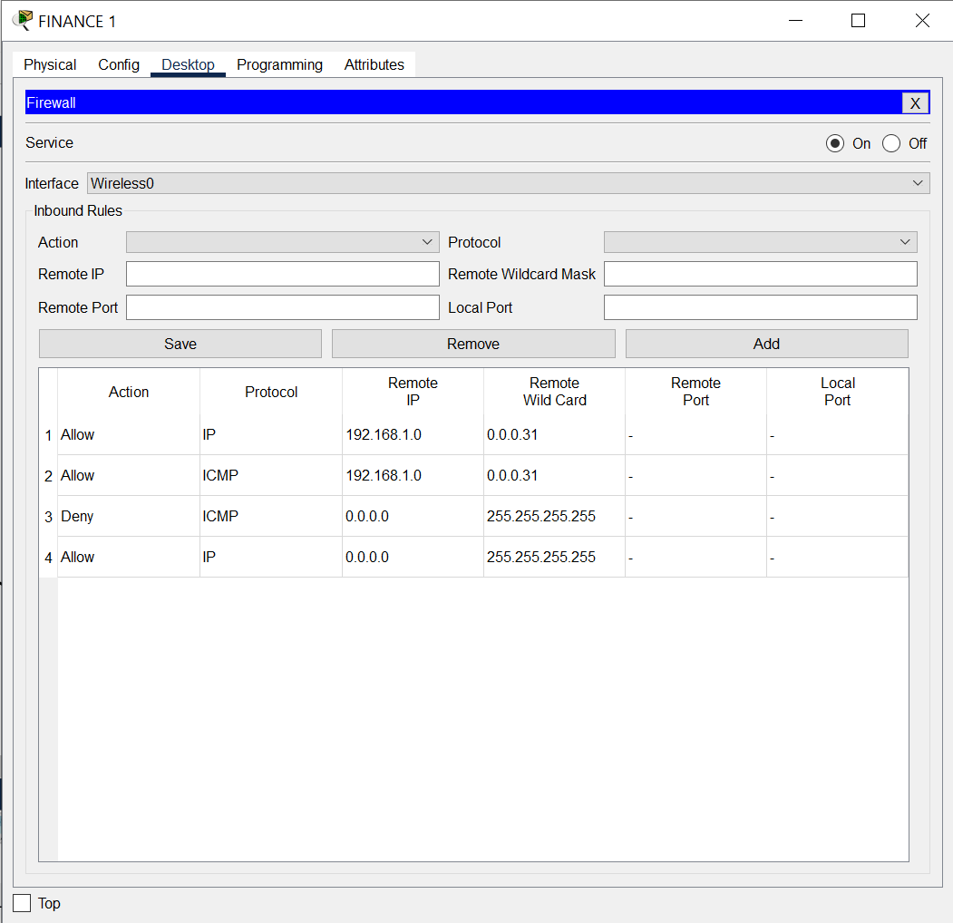

**Every block in its own vlan:**

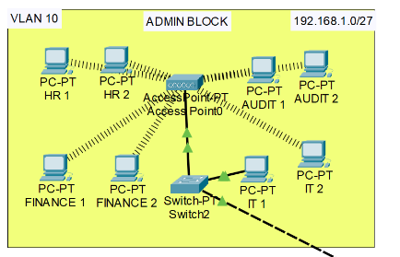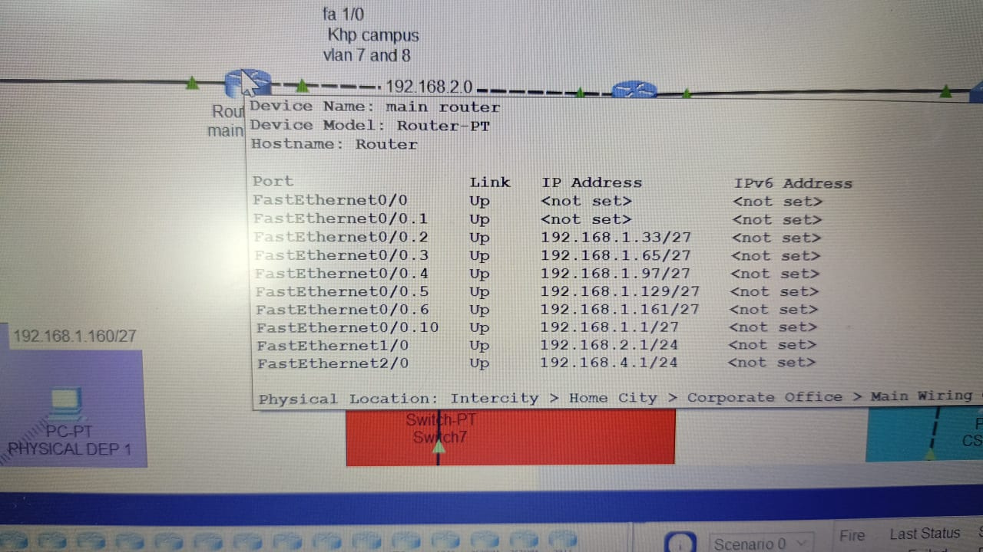

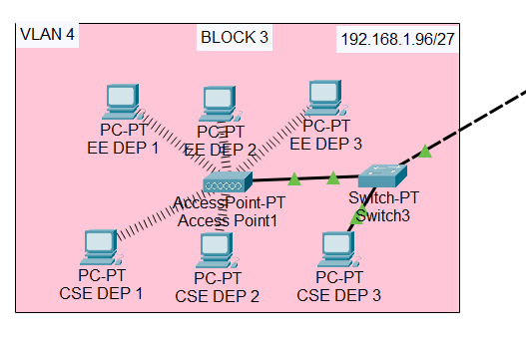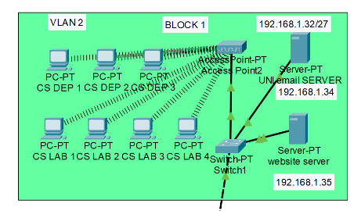

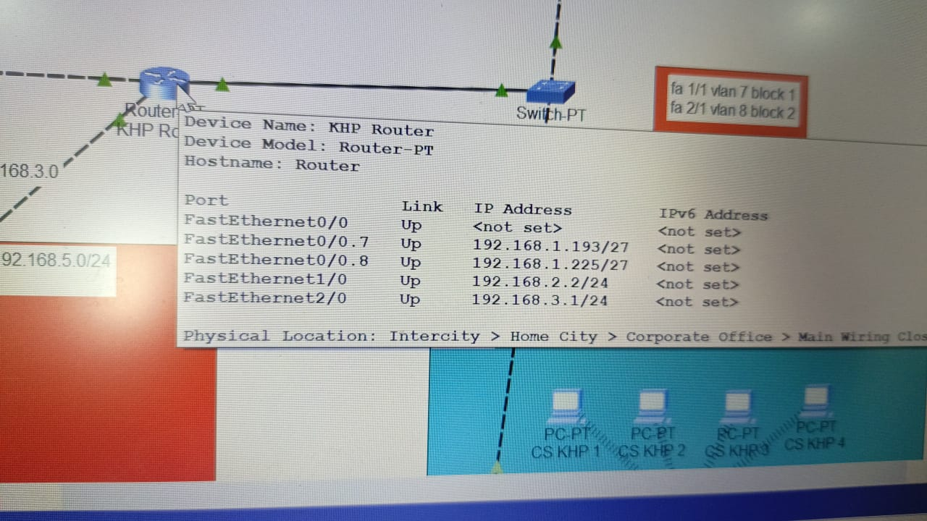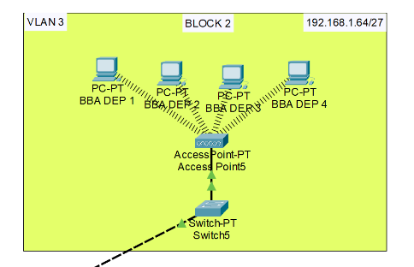

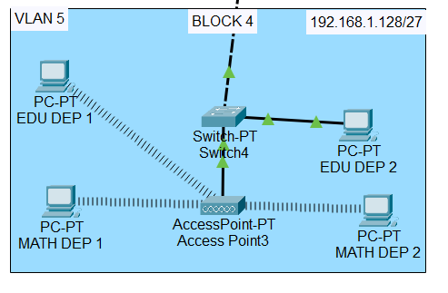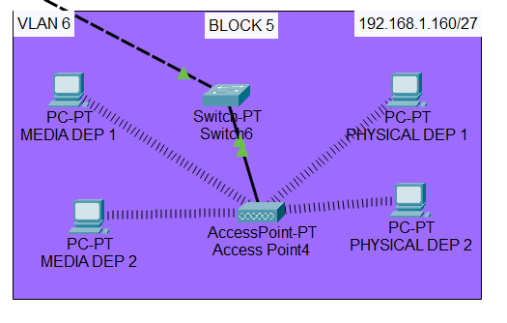

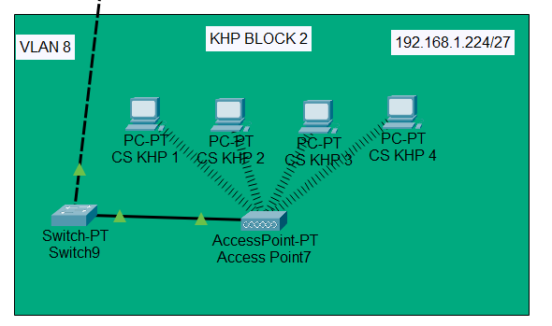

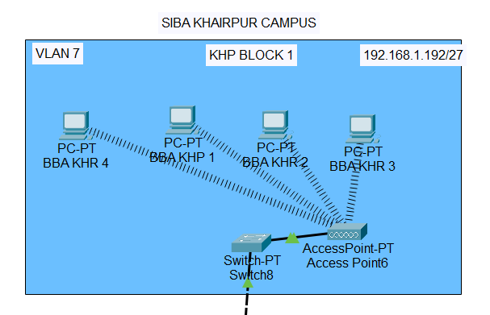

**To check Connectivity Simple PDU message is sent**

**From pc HR 1 in vlan 1**

**To Every vlan pcs including vlan and also to external Server:**

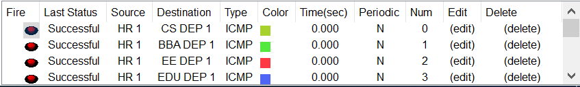

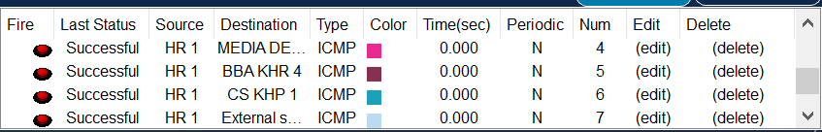

**Dns server has ip 192.168.1.35 located in block 1 – vlan 2:**

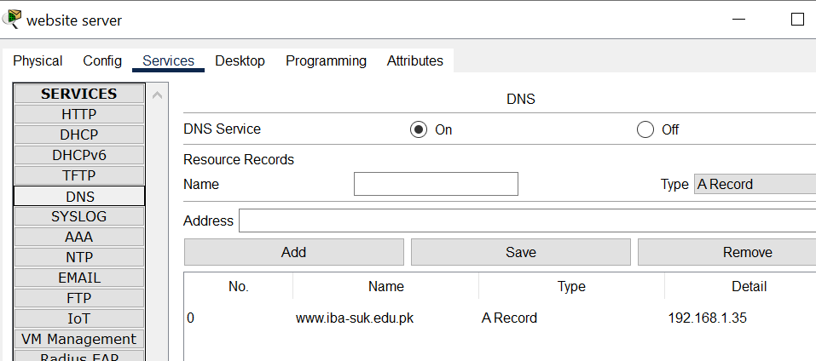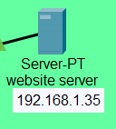

**Accessing Dns server/webpage:**

